**Project Report On**

Electronic Accessories Website

**Submitted By**

Mihir P. Makwana (Seat No. : 5115117)

# Submitted for

In-house Project

BCA Semester - V (2022-23)

# Submitted To



**S.G.M. English Medium College of Commerce and Management**

**(SEMCOM)**

**CVM University**



3/12/2022

2022-23

**____**

**____**

5115117

TYBCA - V

Mihir P. Makwana

In-House Project

**Acknowledgement**

I take this occasion to thank God, almighty for blessing us with his grace and taking my endeavour to a successful culmination. I extend my sincere and heartfelt thanks to our esteemed guide, Ms. **PALAK PATEL** mam, for providing me with the right guidance and advice at the crucial junctures and for showing me the right way. I extend my sincere thanks to college for allowing me to use the facilities available. I would like to thank the other faculty members also, at this occasion. Last but not the least, I would like to thank my friends and family for the support and encouragement they have given me during the course of our work.

**INDEX**

|  |  |  |
| --- | --- | --- |
| **Sr. No.** | **Description of Topic** | **Page No.** |
| **1** | Title Page of Project | 1 |
| **2** | College Certificate | 2 |
| **3** | Acknowledgment | 3 |
| **4** | Index | 4 |
| **5** | Project Profile | 5 |
| **6** | An Existing System | 6 |
| **7** | Data Flow Diagram | 8 |
| **8** | Data Dictionary | 10 |
| **9** | Screen | 12 |
| **10** | Conclusion | 16 |
| **11** | Bibliography | 17 |

**Project Profile**

Tools:

* HTML
* CSS
* JavaScript
* PHP

Introduction:

This project is built with HTML, CSS, JavaScript and PHP.

In this project there are different webpages like, Home, Products, Contact us, Sign in etc. The HTML, CSS and JavaScript are used in frontend and PHP is used to store user’s data and Products details on the server.

The basic concept of this project is to sell different Electronic Accessories. There are different accessories available in the products section.

The HTML and CSS are mainly used in design of this website. The JavaScript is used in form validation and PHP used to store the data.

The user’s data which stored on the server are using PHP and MySQL via WAMP server. The user’s passwords are encrypted so that even owner of the website is also not able to read the passwords.

In the website if user wants to purchase products than He/she must have to register their selves on the website using Sign In page. If they are already registered than they can easily purchase any products just by login using Mobile No. and Password.

Users also able to add products in the cart so that they can purchase it whenever they want.

For create an account on website user need have to feel following data: Name, Mobile Number, Email (Optional), Address, Pin code, District, State, Password.

Features:

* User-Friendly UI
* Product Description
* Easy to Buy
* Order Tracking
* Personal Data Policy

Needs of project:

* Notepad
* WAMP/XAMPP Server
* Min RAM 512MB
* OS Windows 7/8/10

**An Existing System**

* This website has been developed for purchasing products online. This website can handle user’s login info and orders of users.
* This website fetch products details and display it into the webpage.
* The existing system Register information required in the system is entered and maintained totally manually. Manually maintain the customer details personal info.
* This System has a very user friendly interface and user can purchase any item He/she wants, User can also add items in their cart and purchase it whenever they want.
* When user buy a product the order details will be stored in database and user can track record of their orders too.
* To buy a product or add an item to cart user needs to create an account on the system.

**Data Flow Diagram**

Process Hierarchy:

Context Level DFD:

Request for Login Request for Registration

USER

ADMIN

Response Response

Zero - Level DFD:

**Data Dictionary:**

**Users Table – Contains details of Users**

|  |  |  |  |  |
| --- | --- | --- | --- | --- |
| **Column Status** | **Attribute** | **Data Type** | **Size** | **Description** |
| Not Null | Name | VARCHAR | 100 | Name of Customer |
| Not Null, Primary Key | Mobile_No | VARCHAR | 10 | Mobile no. of Customer |
| Not Null | Email | VARCHAR | 50 | Email of Customer |
| Not Null | Address | VARCHAR | 200 | Address of Customer |
| Not Null | Pin code | INT | 8 | Pin code of Customer |
| Not Null | District | VARCHAR | 20 | District of Customer |
| Not Null | State | VARCHAR | 20 | State of Customer |
| Not Null | Password | VARCHAR | 20 | Password of Customer |

**Purchase Table – Contains purchase details of Users**

|  |  |  |  |  |
| --- | --- | --- | --- | --- |
| **Column Status** | **Attribute** | **Data Type** | **Size** | **Description** |
| Not Null | Name | VARCHAR | 100 | Name of Customer |
| Not Null, Primary Key | Mobile_No | VARCHAR | 10 | Mobile no. of Customer |
| Not Null | Password | VARCHAR | 20 | Password of Customer |
| Not Null | P_Id | VARCHAR | 5 | Product ID |
| Not Null | Product | INT | 250 | Product Name |
| Not Null | Price | VARCHAR | 20 | Price of Product |

**Contact details Table – Contains contact details and feedback of Users**

|  |  |  |  |  |
| --- | --- | --- | --- | --- |
| **Column Status** | **Attribute** | **Data Type** | **Size** | **Description** |
| Not Null | Name | varchar | 100 | Name of Customer |
| Not Null | Phone | varchar | 10 | Mobile no. of Customer |
| Not Null | Email | varchar | 100 | Email of Customer |
| Not Null | Message | varchar | 500 | Customer Message |

**Screens**

**Home**

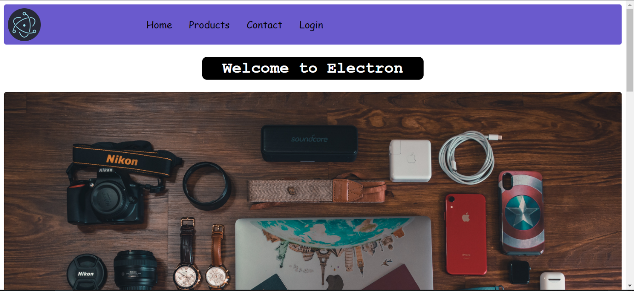

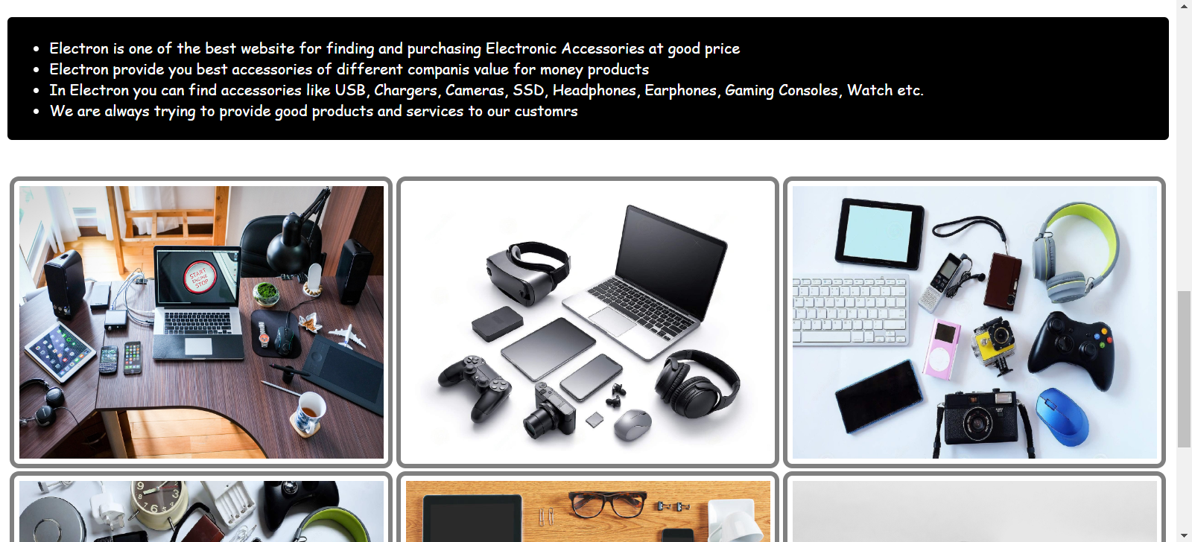

**Products**

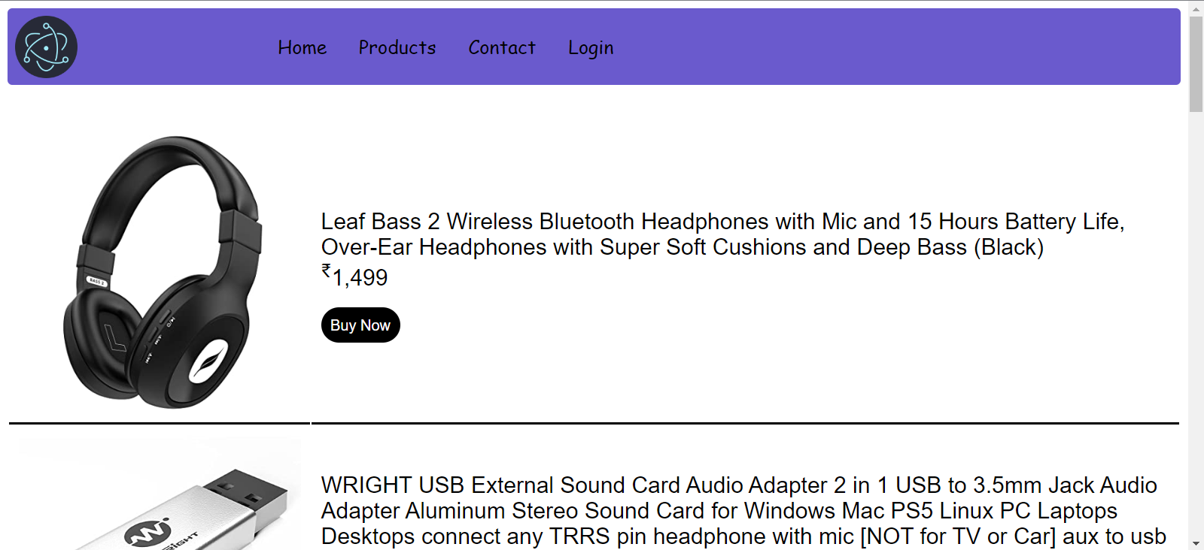

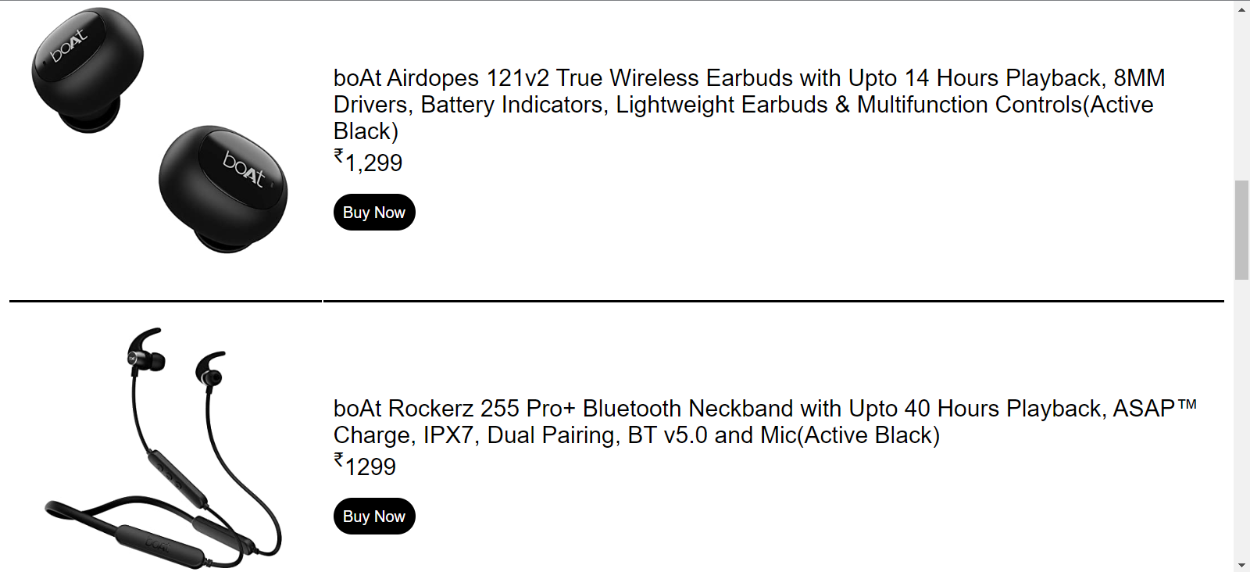

**Contact us**

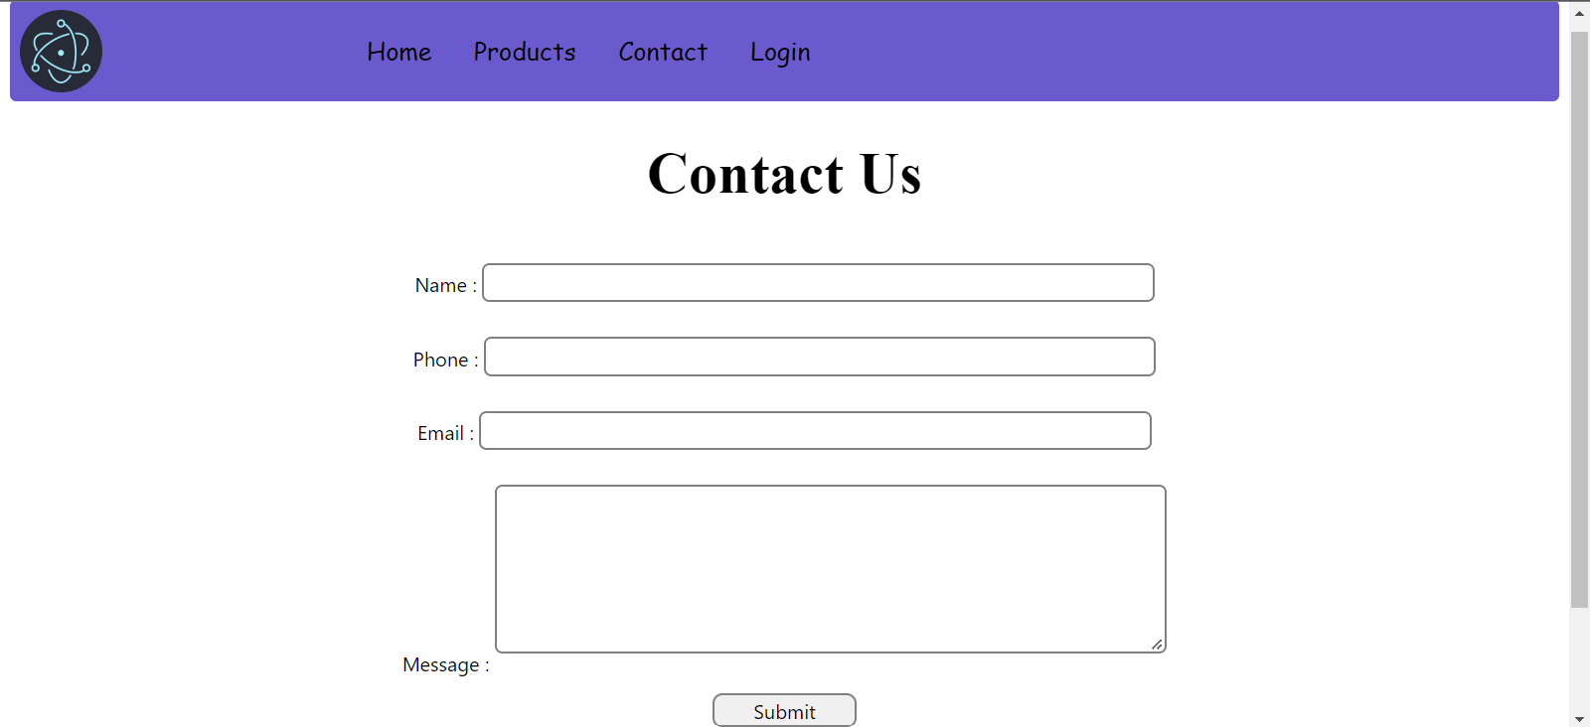

**Sign In**

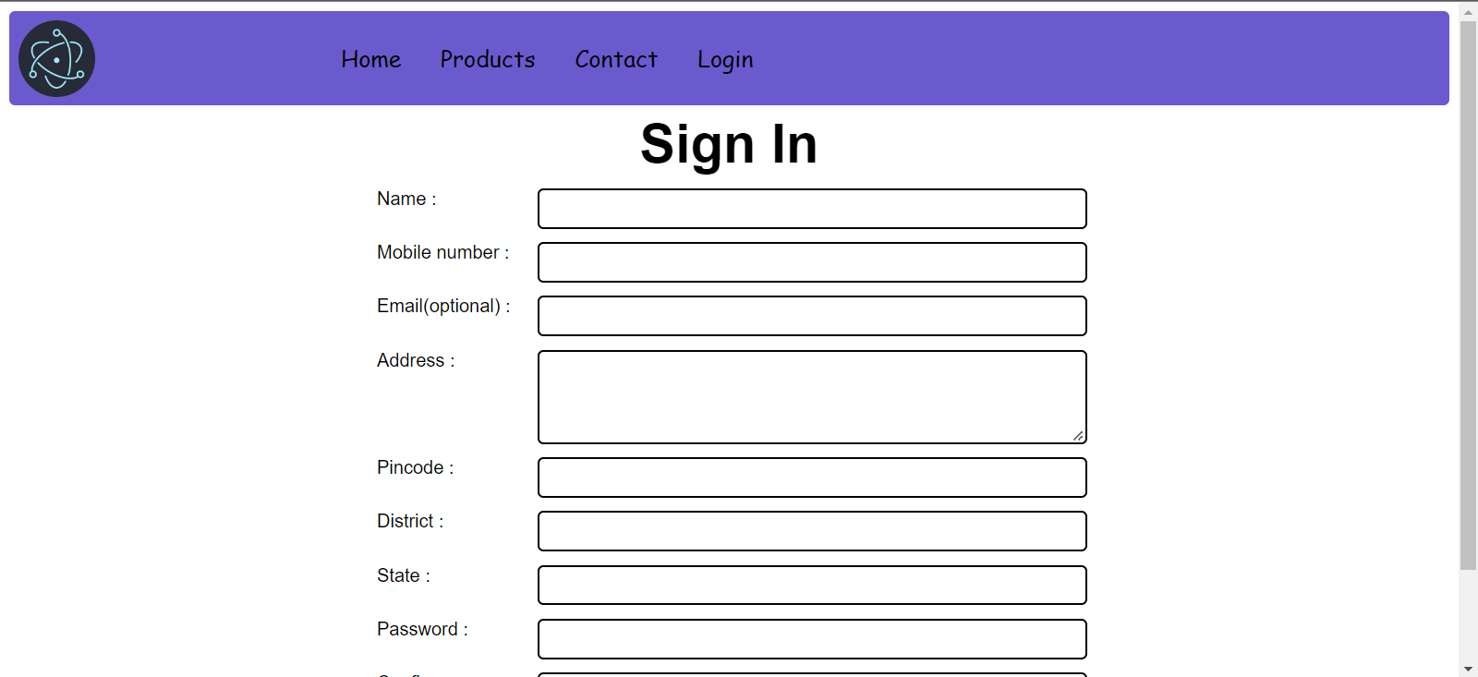

**Log In**

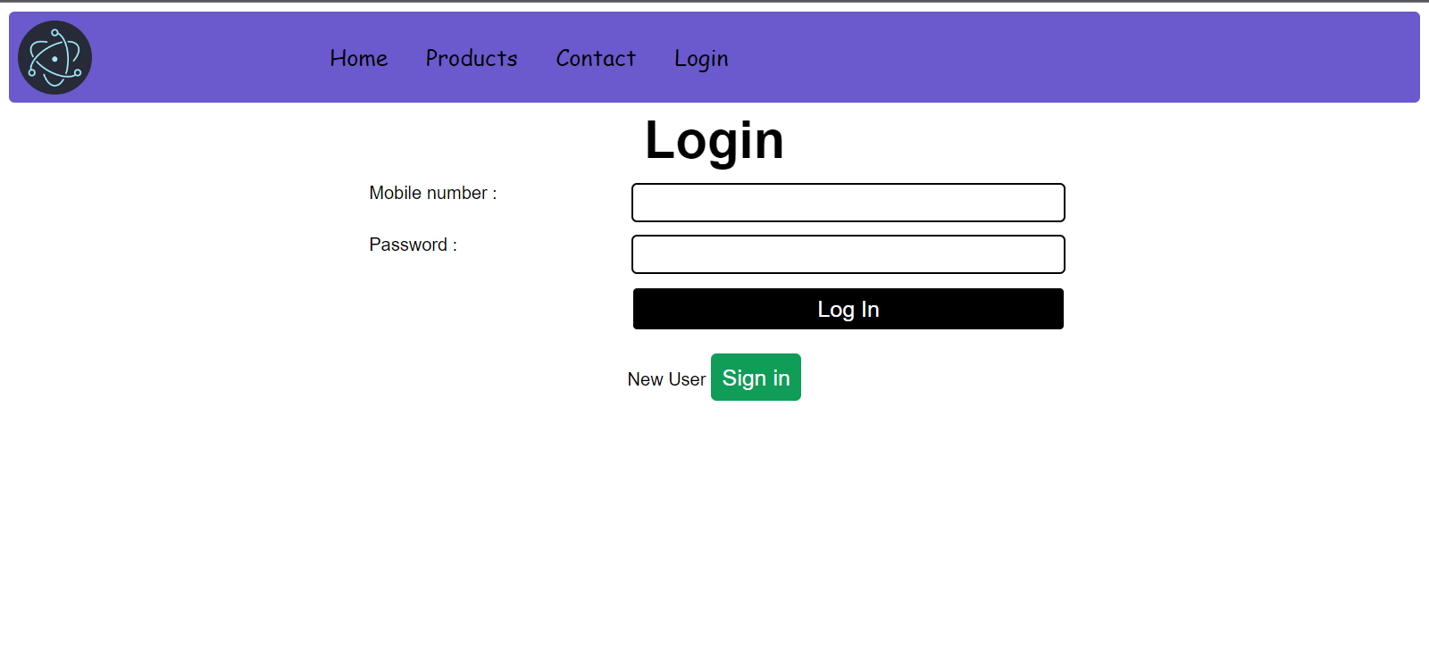

**Conclusion**

The project entitled Online shopping system was completed successfully. The system has been developed with much care and free of errors and at the same time it is efficient and less time consuming. The purpose of this project was to develop a web application and an android application for purchasing items from a shop. This project helped us in gaining valuable information and practical knowledge on several topics like designing web pages using HTML & CSS, usage of responsive templates, designing of android applications, and management of database using MySQL. The entire system is secured. Also the project helped us understanding about the development phases of a project and software development life cycle. We learned how to test different features of a project. This project has given us great satisfaction in having designed an application which can be implemented to any nearby shops or branded shops selling various kinds of products by simple modifications. There is a scope for further development in our project to a great extent. A number of features can be added to this system in future like providing moderator more control over products so that each moderator can maintain their own products. Another feature we wished to implement was providing classes for customers so that different offers can be given to each class. System may keep track of history of purchases of each customer and provide suggestions based on their history. These features could have implemented unless the time did not limited us.

**Bibliography**

* Website Reference:

<https://www.google.com/>

<https://www.youtube.com/>

<https://stackoverflow.com/>

<https://www.w3schools.com/php/>

<https://www.w3schools.com/html/>

<https://www.w3schools.com/css/>

<https://www.w3schools.com/js/>